- The Monetary Policy Committee voted to keep Bank Rate at 4% at its meeting this week. The vote was very tight, with Governor Bailey again the swing voter. His messaging was dovish and suggested that the bar to him switching vote in December is low. Assuming inflation falls back in the next two releases and the Budget tightens fiscal policy, a December cut now appears likely.
- The MPC remains deeply divided, so votes are likely to remain close. The guidance suggested that Bank Rate is likely to be cut further, provided disinflation continues. Most of the MPC still think policy is restrictive, and we expect that activity will disappoint their expectations. So we anticipate two 25bp cuts next year, which would take Bank Rate to 3.25% by end-2026.
Since August, the Bank of England's Monetary Policy Committee had been hinting it would break its 'cut-hold' pattern of lowering Bank Rate. This week saw the committee confirm that move, but the 5-4 vote to hold Bank Rate at 4% for a second consecutive meeting was closer than expected. Furthermore, the committee's core message was relatively dovish and suggested a December rate cut is very much in play.
For the first time, November's meeting minutes included a paragraph from each member summarising their views. Governor Andrew Bailey has emerged as the committee's swing voter in recent months, and his paragraph indicated that his deciding vote for a hold was a close call. He remarked that "the latest CPI data were promising" and that "upside risks to inflation have become less pressing". And perhaps most telling, Bailey concluded his paragraph by saying "rather than cutting Bank Rate now, I would prefer to wait and see if the durability in disinflation is confirmed in upcoming economic developments this year".
At the risk of taking Bailey's comments too literally, his reference to "economic developments this year" appears to be a nod to the data that will be published ahead of December's meeting and this month's Budget. The Governor's comments on inflation gave the impression that further progress on headline inflation in the two releases before the December meeting will be key to whether he will be willing to switch his vote to a cut. Similar to the BoE's new staff forecast, we expect inflation to cool slightly before the December meeting (Chart 1).
Chart 1: We expect the next two CPI readings to be lower than September's
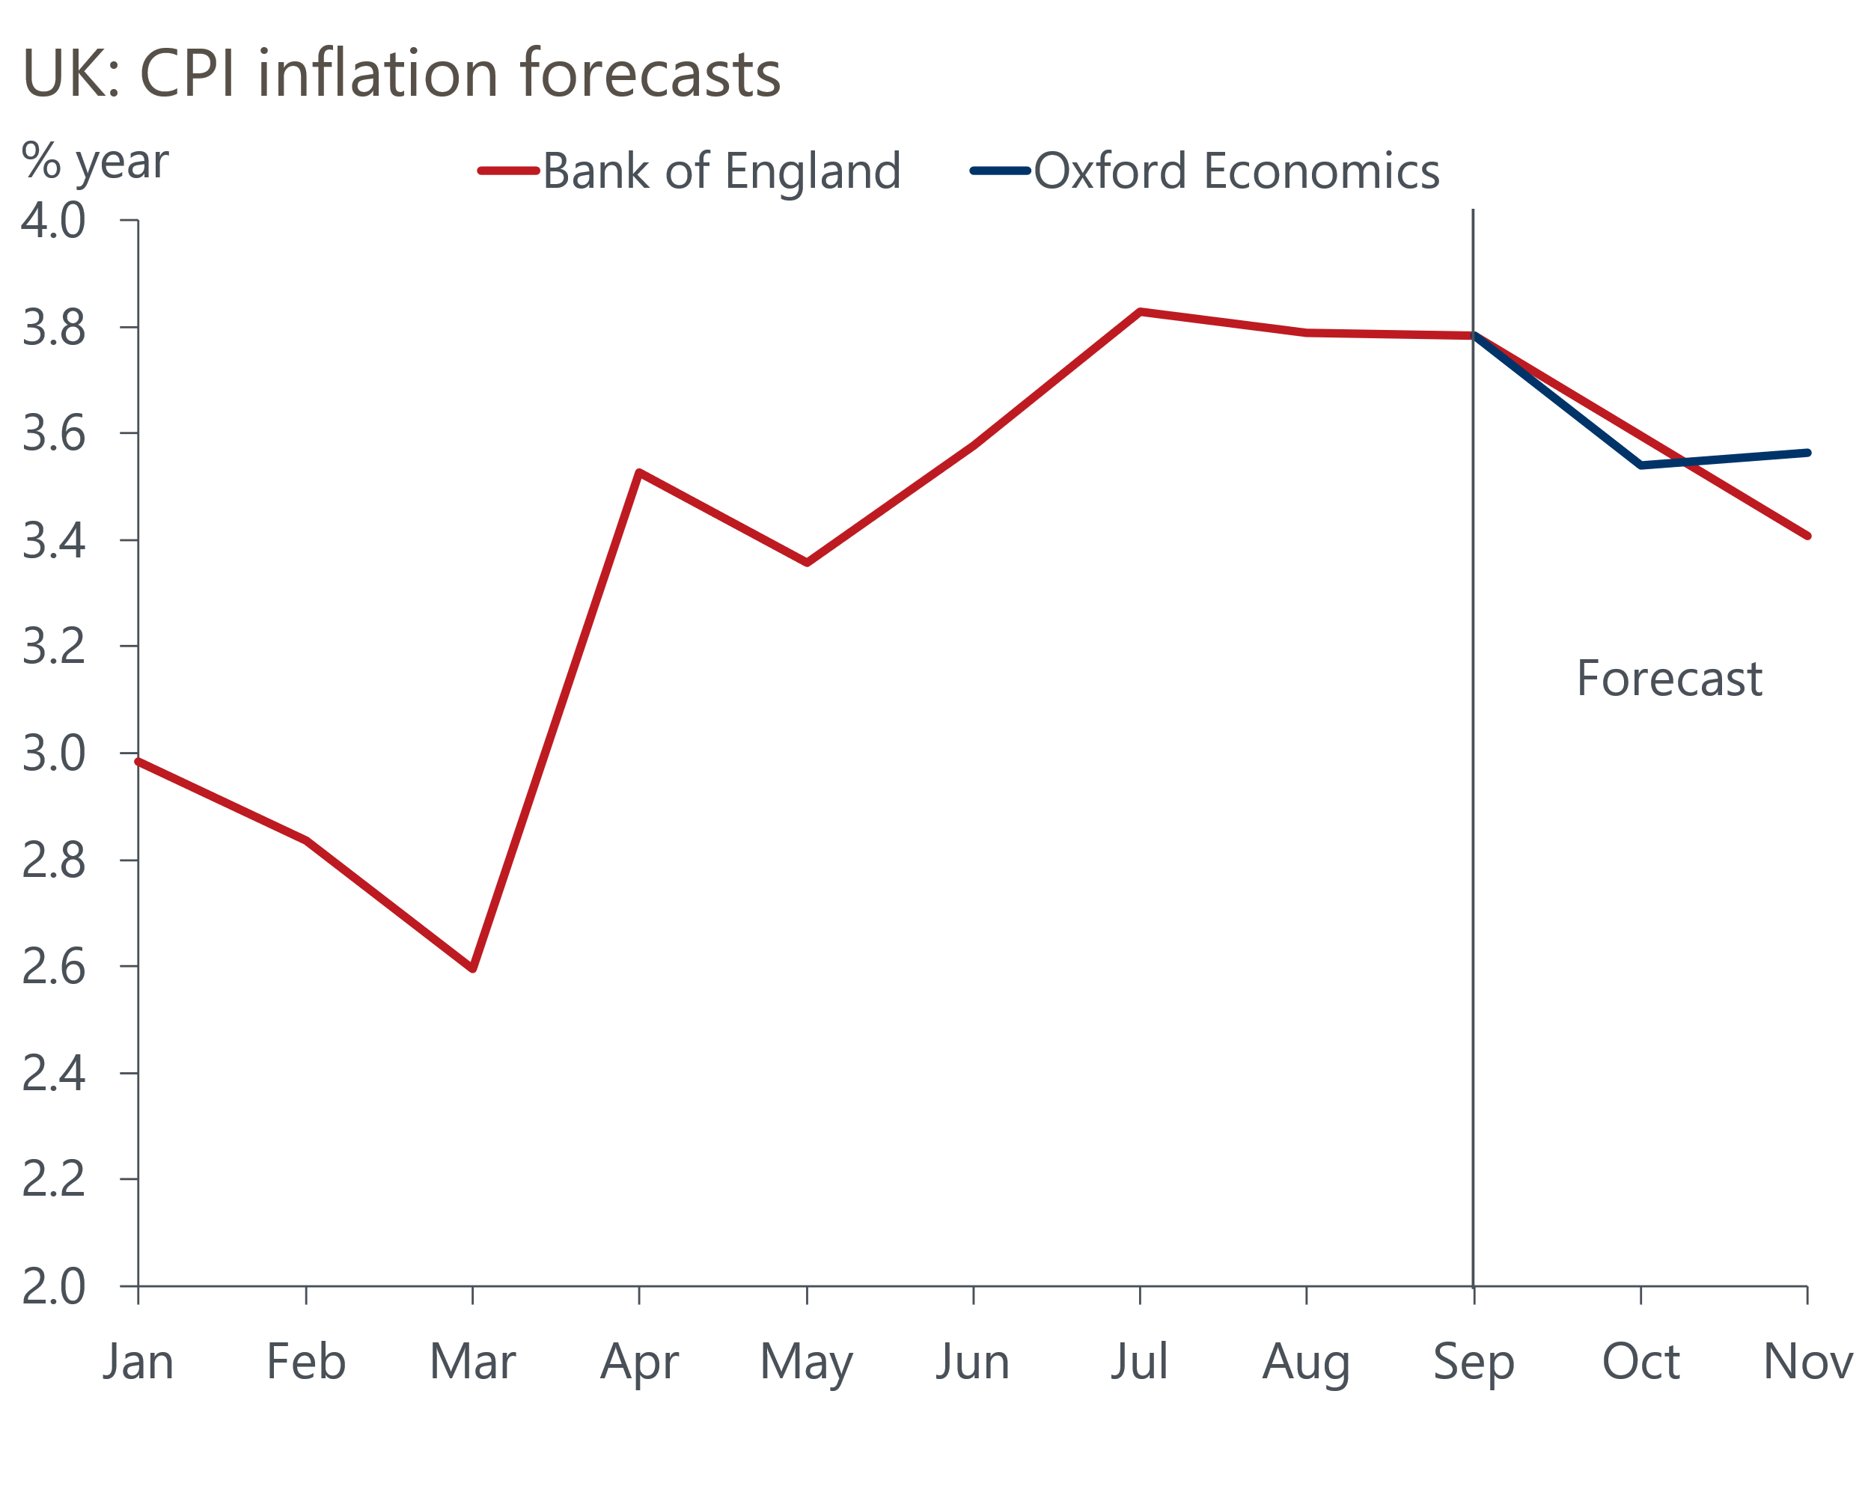
Sources: Oxford Economics, Bank of England

Two developments suggest the Budget will also increase the chances of a cut in December. First, it appears Chancellor Rachel Reeves is increasingly likely to target a larger increase in headroom against her fiscal rules, suggesting that more tightening will be required. Second, in a speech on Tuesday, the Chancellor sent the strongest signal yet that her upcoming Budget will include an increase in the main rate of income tax, which would mean the tightening is more front-loaded.
At the August meeting, concerns about inflation persistence dominated for most of the MPC. But members felt that the risks to activity and inflation have now moved into balance. If the Budget implements a larger and more front-loaded tightening of fiscal policy, this will increase downside risks to demand and inflation. Under these circumstances, Bailey will surely switch to vote for a cut, so we now lean towards a 25bp cut in December.
The individual statements from other MPC members showed a wide range of views on the balance of risks. The Monetary Policy Report presented two scenarios: one in which high past inflation remained influential in price and wage setting in the future; and another in which soft demand, driven by consumer spending weakness, causes inflationary pressures to cool more quickly. These scenarios were presented relative to a central forecast, which most of the MPC considered to be a "reasonable baseline" (Chart 2).
Chart 2: MPC members remain deeply divided on the outlook for inflation
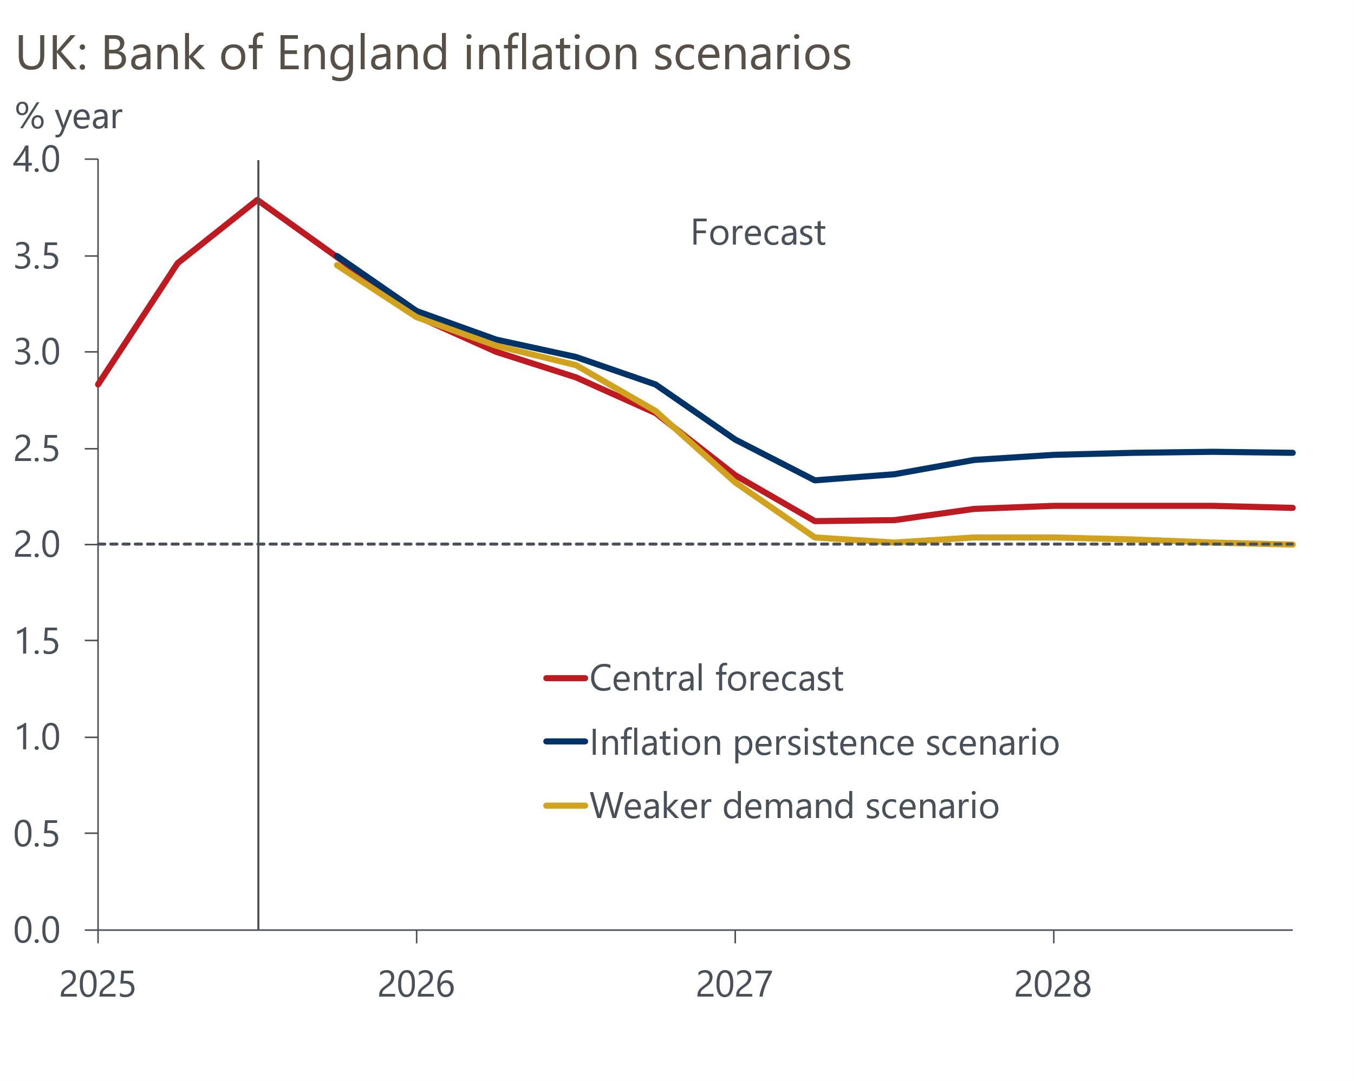
Source: Bank of England
Alan Taylor and Swati Dhingra have consistently argued that the current path for Bank Rate is overly restrictive and risks inflation undershooting the 2% target in the medium term. Both members suggested that they put the highest weight on an outcome closest to the downside scenario. At the other end of the spectrum, Megan Greene, Catherine Mann, and Huw Pill referenced concerns around elevated inflation expectations that echoed the upside scenario. Meanwhile, Clare Lombardelli found elements of both the upside and downside scenarios compelling, but favours a cautious approach to cutting on risk management grounds.
The wide spread of views on the MPC suggest that votes are likely to remain close for the foreseeable future. It's clear that the four dissenters believe the balance of risks is firmly tilted towards further easing. Four of the five who voted for a hold this week think the polar opposite, with Bailey somewhere in the middle.
It was notable that Bailey effectively endorsed market pricing in his paragraph – coming into the November meeting, this implied a little over two 25bps rate cuts by the end of 2026. We think there's a strong chance that activity surprises the committee on the downside over the coming year. So after a December cut, we expect the MPC to cut twice more next year. We will publish our new forecast on November 12, and this will show Bank Rate reaching 3.25% by the end of 2026 – 25bps lower than our previous forecast.

The week ahead
There are two major Office for National Statistics releases next week. The first is Tuesday's labour market data for the July to September period. Pay growth has been cooling in recent months, and strong base effects, particularly for regular pay growth, mean we expect this trend to continue. We forecast headline (three-month average of the annual rate) total pay growth to come in at 4.9%, with regular pay growth at 4.6%.
On the quantities side, results from the Labour Force Survey remain very volatile. Last month's release saw a large spike in August's single-month unemployment rate drive up the three-month average that the ONS reports as its headline rate. Though we expect September's single-month reading to fall back to more normal levels, the three-month average is likely to have edged slightly higher to 4.9% in the three months to September.
Thursday will see the release of GDP data for September. August saw a modest rise in output growth, and though economic activity is likely to have picked up again in September, the drivers of this should look very different. We think there's some scope for a rebound in construction output in September, with the weakness seen in August unlikely to have been sustained. Meanwhile, the drag on transport output from five days of strike action on the London Underground suggests services activity is likely to have flatlined in September. We estimate that GDP rose by 0.2% month-on-month in September.
Table 1: Week ahead calendar
Date | Events | Period | Measure | Unit | Previous | Forecast
Nov 11 | LFS unemployment | Jul-Sep | Rate | % | 4.8 | 4.9
Nov 11 | Average earnings (total pay) | Sep | 3m, y/y | % | 5.0 | 4.9
Nov 11 | Average earnings (regular pay) | Sep | 3m, y/y | % | 4.7 | 4.6
Nov 13 | GDP | Sep | m/m | % | 0.1 | 0.2
Nov 13 | GDP | Sep | 3m/3m | % | 0.3 | 0.2
Nov 13 | Index of services | Sep | m/m | % | 0.1 | 0.0
Nov 13 | Index of services | Sep | 3m/3m | % | 0.4 | 0.3
Nov 13 | Manufacturing output | Sep | m/m | % | 0.7 | -0.1
Nov 13 | Manufacturing output | Sep | y/y | % | -0.8 | -0.7
Nov 13 | Industrial production | Sep | m/m | % | 0.4 | -0.1
Nov 13 | Industrial production | Sep | y/y | % | -0.7 | -0.8
Nov 13 | Construction output | Sep | m/m | % | -0.3 | 0.2
Nov 13 | Construction output | Sep | y/y | % | 1.0 | 1.2
Nov 13 | UK trade | Sep | Trade balance | £bn | -3.4 | -3.0
Nov 13 | UK trade | Sep | Visible balance | £bn | -21.2 | -20.5
Source: Oxford Economics

Key forecasts
Table 2: UK forecast overview
(Annual percentage changes unless specified)
 | 2023 | 2024 | 2025 | 2026 | 2027 | 2028
GDP | 0.3 | 1.1 | 1.5 | 0.9 | 1.3 | 1.7
Private consumption | -0.3 | -0.2 | 1.0 | 1.1 | 1.1 | 1.7
Fixed investment | 0.5 | 1.8 | 2.1 | 0.5 | 1.5 | 2.0
Government consumption | 2.1 | 3.4 | 2.1 | 1.7 | 1.6 | 1.7
Exports of goods and services | -2.3 | 0.6 | 3.0 | 0.2 | 1.2 | 1.5
Imports of goods and services | -1.6 | 2.6 | 3.9 | -0.5 | 1.2 | 1.5
Industrial production | -2.6 | -1.6 | -0.3 | -0.1 | 1.1 | 1.3
Consumer prices | 7.3 | 2.5 | 3.4 | 2.8 | 2.5 | 2.2
Unemployment rate (%) | 4.1 | 4.3 | 4.7 | 4.9 | 4.8 | 4.4
Current a/c balance (% of GDP) | -3.6 | -2.2 | -3.1 | -2.6 | -2.4 | -2.3
Government balance (% of GDP) | 5.2 | 5.2 | 4.8 | 3.5 | 3.1 | 2.7
Central bank policy rate (%, EOP) | 5.25 | 4.75 | 3.75 | 3.25 | 3.00 | 2.75
10yr govt. bond yield (%, EOP) | 3.54 | 4.57 | 4.60 | 4.24 | 3.76 | 3.48
Exchange rate (US$ per £, EOP) | 1.27 | 1.25 | 1.29 | 1.29 | 1.29 | 1.29
Exchange rate (euro per £, EOP) | 1.15 | 1.21 | 1.11 | 1.11 | 1.11 | 1.11
Source: Oxford Economics
Table 3: Quarterly forecasts for the UK
 | 2025 |  |  |  | 2026
 | Q1 | Q2 | Q3 | Q4 | Q1 | Q2 | Q3 | Q4
GDP (% year) | 1.7 | 1.4 | 1.4 | 1.3 | 0.9 | 0.9 | 0.9 | 1.0
CPI inflation (% year) | 2.8 | 3.5 | 3.8 | 3.6 | 3.3 | 2.5 | 2.7 | 2.6
Bank Rate (%, EOP) | 4.50 | 4.25 | 4.00 | 3.75 | 3.75 | 3.50 | 3.50 | 3.25
10yr gilt yield (%, EOP) | 4.70 | 4.48 | 4.70 | 4.60 | 4.57 | 4.49 | 4.38 | 4.24
US$ per £ (EOP) | 1.29 | 1.37 | 1.35 | 1.29 | 1.29 | 1.29 | 1.29 | 1.29
Euro per £ (EOP) | 1.20 | 1.17 | 1.15 | 1.11 | 1.11 | 1.11 | 1.11 | 1.11
Source: Oxford Economics

Latest Country Economic Forecast:
October 13, 2025

Recent publications

Data Insights
Services sector shows few signs of Budget fears
October's stronger manufacturing PMI is unlikely to be sustained
Mortgage activity has stabilised after distortions earlier this year
PMI points to soft pre-Budget growth
Retail sales surged again in September

Research Briefings
Dovish hold in November puts a December rate cut in play
MPC preview – softer data unlikely to herald November cut
What should the Chancellor do in the Budget?
What happens if markets lose faith in the fiscal approach?
What will the Chancellor do in the Budget?

Contacts

Oxford Economics' UK team
- Andrew Goodwin - Chief UK Economist - agoodwin@oxfordeconomics.com
- Edward Allenby - Senior UK Economist - eallenby@oxfordeconomics.com

